EXPERIMENT 6

Aim:
To create a stored procedure transfer_employee(emp_id, new_dept_id) with validation and error handling, and to implement triggers for salary validation and audit logging. Also, to test different edge cases.

SOURCE CODE:

1. Create Department Table:
CREATE TABLE Department6 (
dept_id INT PRIMARY KEY,
dept_name VARCHAR(30)
);

2. Insert Department Data:
INSERT INTO Department6 VALUES
(1, 'IT'),
(2, 'HR'),
(3, 'Finance'),
(4, 'Marketing');

3. Create Employee Table:
CREATE TABLE Employee6 (
emp_id INT PRIMARY KEY,
emp_name VARCHAR(30),
dept_id INT,
salary DECIMAL(10,2),
FOREIGN KEY (dept_id) REFERENCES Department6(dept_id)
);

4. Insert Employee Data:
INSERT INTO Employee6 VALUES
(101, 'Riya', 1, 75000),
(102, 'Aradhana', 1, 65000),
(103, 'Shatakshi', 2, 60000),
(104, 'Aman', 2, 55000),
(105, 'Priya', 3, 70000);

5. Create Audit Table:
CREATE TABLE Employee_Audit6 (
audit_id INT AUTO_INCREMENT PRIMARY KEY,
emp_id INT,
old_dept_id INT,
new_dept_id INT,
changed_at TIMESTAMP DEFAULT CURRENT_TIMESTAMP
);

6. Trigger for Salary Validation:
This trigger prevents an employee from having a salary less than or equal to zero.
CREATE TRIGGER validate_salary6
BEFORE INSERT ON Employee6
FOR EACH ROW
BEGIN
IF NEW.salary <= 0 THEN
SIGNAL SQLSTATE '45000'
SET MESSAGE_TEXT = 'Salary must be greater than zero';
END IF;
END;

7. Trigger for Salary Validation During UPDATE:

CREATE TRIGGER validate_salary_update6
BEFORE UPDATE ON Employee6
FOR EACH ROW
BEGIN
IF NEW.salary <= 0 THEN
SIGNAL SQLSTATE '45000'
SET MESSAGE_TEXT = 'Salary must be greater than zero';
END IF;
END;

8. Trigger for Audit Logging:
This trigger records the old and new department whenever an employee's department is changed.
CREATE TRIGGER employee_transfer_audit6
AFTER UPDATE ON Employee6
FOR EACH ROW
BEGIN
IF OLD.dept_id <> NEW.dept_id THEN
INSERT INTO Employee_Audit6
(emp_id, old_dept_id, new_dept_id)
VALUES
(OLD.emp_id, OLD.dept_id, NEW.dept_id);
END IF;
END;

9. Create Stored Procedure transfer_employee:
The procedure checks whether the employee and new department exist before transferring the employee.
CREATE PROCEDURE transfer_employee(
IN p_emp_id INT,
IN p_new_dept_id INT
)
BEGIN
DECLARE v_count INT DEFAULT 0;

DECLARE EXIT HANDLER FOR SQLEXCEPTION
BEGIN
ROLLBACK;
SIGNAL SQLSTATE '45000'
SET MESSAGE_TEXT = 'Error occurred while transferring employee';
END;

START TRANSACTION;

SELECT COUNT(*)
INTO v_count
FROM Employee6
WHERE emp_id = p_emp_id;

IF v_count = 0 THEN
SIGNAL SQLSTATE '45000'
SET MESSAGE_TEXT = 'Employee does not exist';
END IF;

SELECT COUNT(*)
INTO v_count
FROM Department6
WHERE dept_id = p_new_dept_id;

IF v_count = 0 THEN
SIGNAL SQLSTATE '45000'
SET MESSAGE_TEXT = 'Department does not exist';
END IF;

UPDATE Employee6
SET dept_id = p_new_dept_id
WHERE emp_id = p_emp_id;

COMMIT;
END;

10. Display Employee Data Before Transfer:
SELECT * FROM Employee6;

Output:

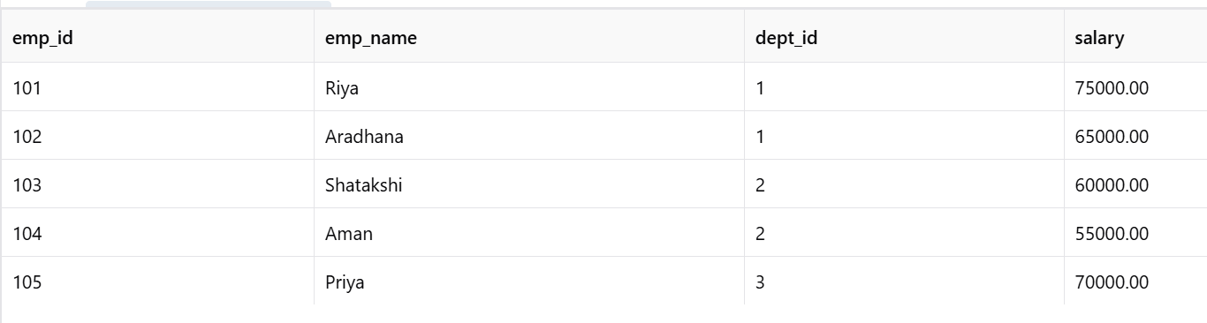

11. Test Stored Procedure – Successful Transfer:
Transfer employee 102 from IT to Finance.
CALL transfer_employee(102, 3);

Output:
Query OK

Verify the Transfer:
SELECT * FROM Employee6
WHERE emp_id = 102;

Output:

12. Check Audit Log:
SELECT * FROM Employee_Audit6;

Output:
audit_id | emp_id | old_dept_id | new_dept_id
1 | 102 | 1 | 3

13. Test Invalid Employee ID:
CALL transfer_employee(999, 2);

Output:
ERROR 1644 (45000): Employee does not exist

14. Test Invalid Department ID:
CALL transfer_employee(101, 99);

Output:
ERROR 1644 (45000): Department does not exist

15. Test Salary Validation Trigger:
Try inserting an employee with an invalid salary.
INSERT INTO Employee6
VALUES (106, 'Karan', 1, -5000);

Output:
ERROR 1644 (45000): Salary must be greater than zero
The invalid employee is not inserted.

16. Test Salary Update Validation:
UPDATE Employee6
SET salary = -1000
WHERE emp_id = 101;

Output:
ERROR 1644 (45000): Salary must be greater than zero
The salary remains unchanged.

17. Test Valid Salary Update:
UPDATE Employee6
SET salary = 80000
WHERE emp_id = 101;

Output:
1 row affected

Verify:
SELECT * FROM Employee6
WHERE emp_id = 101;

Output:

18. Test Another Employee Transfer:
CALL transfer_employee(105, 4);

Output:
Query OK

Verify:
SELECT * FROM Employee6
WHERE emp_id = 105;

Output:

19. Final Audit Log:
SELECT
audit_id,
emp_id,
old_dept_id,
new_dept_id,
changed_at
FROM Employee_Audit6;

Output:
audit_id | emp_id | old_dept_id | new_dept_id | changed_at
1 | 102 | 1 | 3 | Current timestamp
2 | 105 | 3 | 4 | Current timestamp

Result:
Thus, the stored procedure transfer_employee(emp_id, new_dept_id) was successfully created with validation and error handling. Triggers were implemented for salary validation and employee transfer audit logging, and valid as well as invalid test cases were successfully executed.

